Name: Kamal Agrahari Lab: DevOps

ID: VU4F2223028 Class: TE / A

**Experiment No. 11**

Aim: Building Docker Image. Theory:

 What is a Docker Image?

− A Docker image is a lightweight, stand-alone, and executable package that includes everything needed to run an application, including the code, runtime, libraries, environment variables, and configuration files.

− Images are immutable, meaning once they are created, they cannot be changed. Instead, new

images are built on top of existing images.

 Key Characteristics of Docker Images:

− Layered File System: Docker images are composed of layers. Each layer represents a set of file changes or operations, such as adding files, modifying files, or installing software. This layering system allows for efficient storage and sharing since multiple images can share common layers.

− Read-Only: Once an image is created, it becomes read-only. Any changes made to a running container (an instance of the image) are stored in a new writable layer on top of the image.

− Versioning: Images can be tagged and versioned, allowing you to manage different versions of your application easily.

 Building a Docker Image

1. Create a Dockerfile

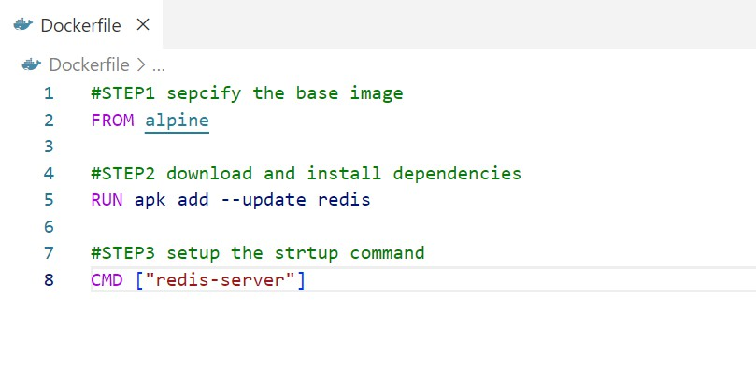

2. Build the Docker Image

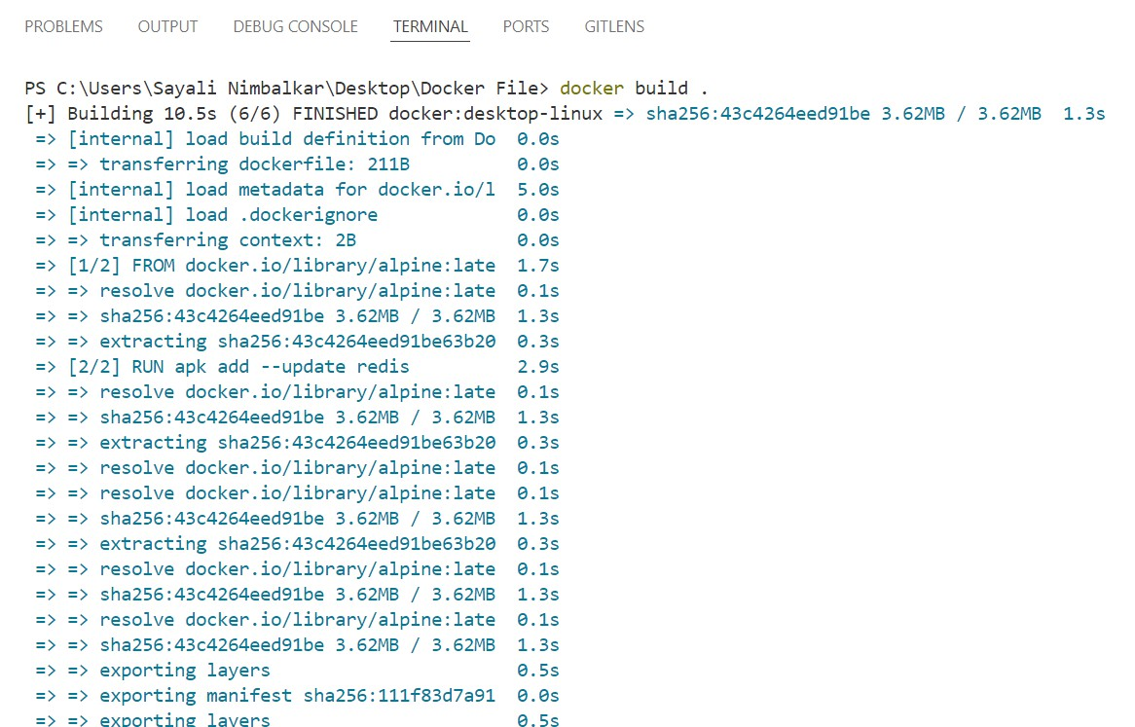

3. Verify the Built Image

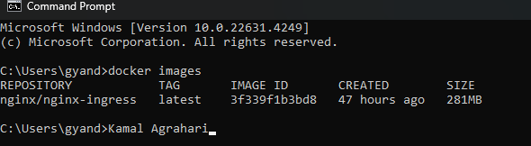

4. Run the image by the “image ID” to check if it’s working correctly.

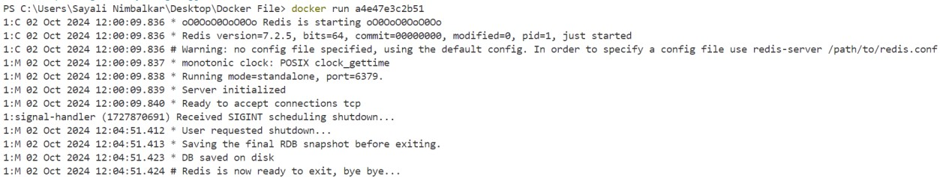

5. Tagging a name to the image.

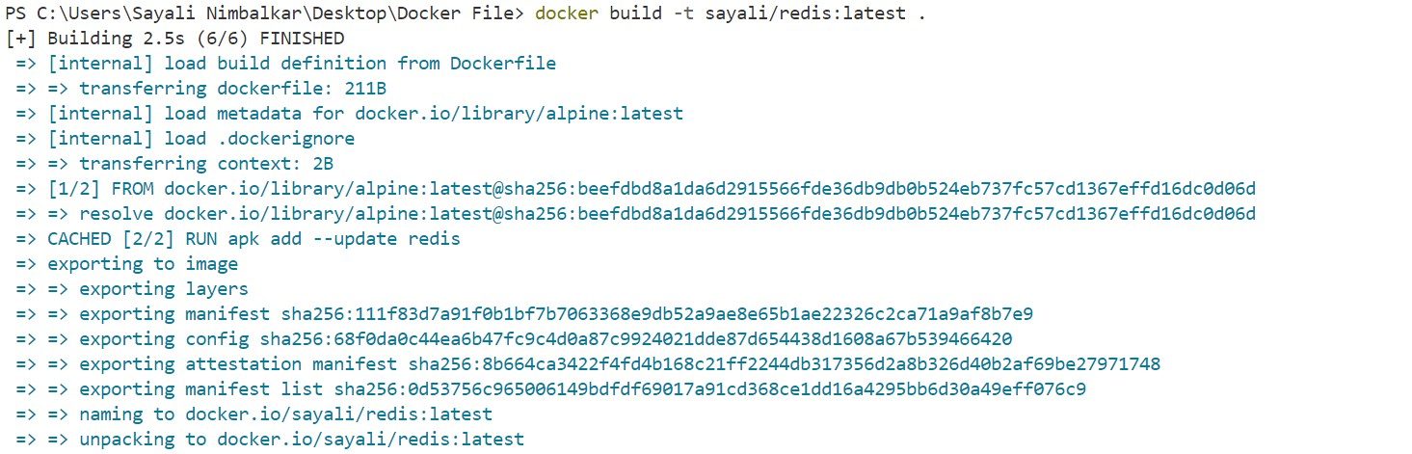

6. Running the image by given name.

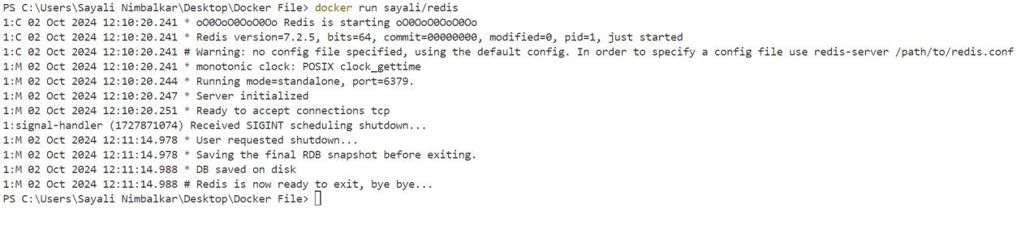

7. Verifying it.



8. You can see the image in your docker desktop.

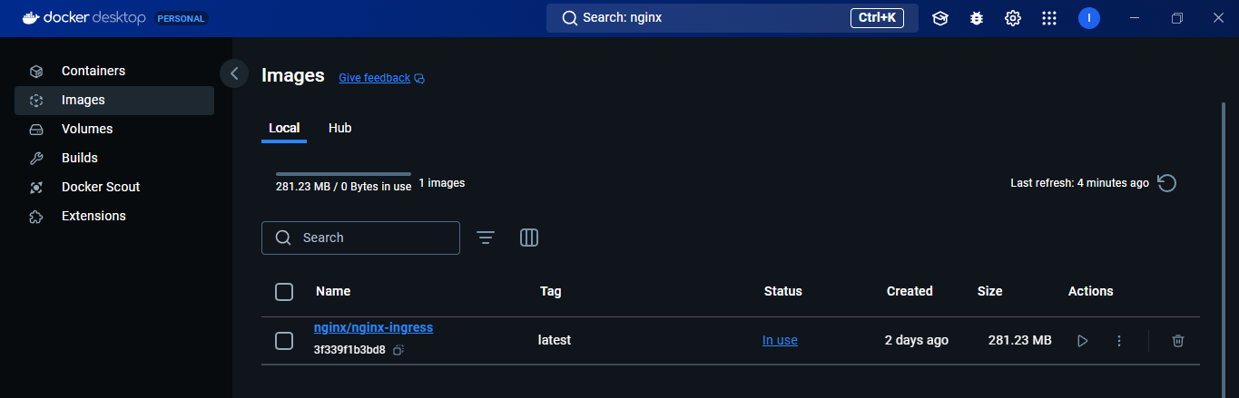

Conclusion:

Hence, we successfully build the Docker image.